**Request to run Direct Bill Statement Report**   
  
Step1:  
  
Login to **10.90.151.132** SST Server  
  
step2:  
  
Go to below path  
C:\Report Builder  
  
Double click on MP_Report_Builder application  
  
Click on Open report,  
  
  
Go to System Reports, expand reports  
  
Navigate to Direct Bill Statement Report (As per report name mentioned in the mail)  
  
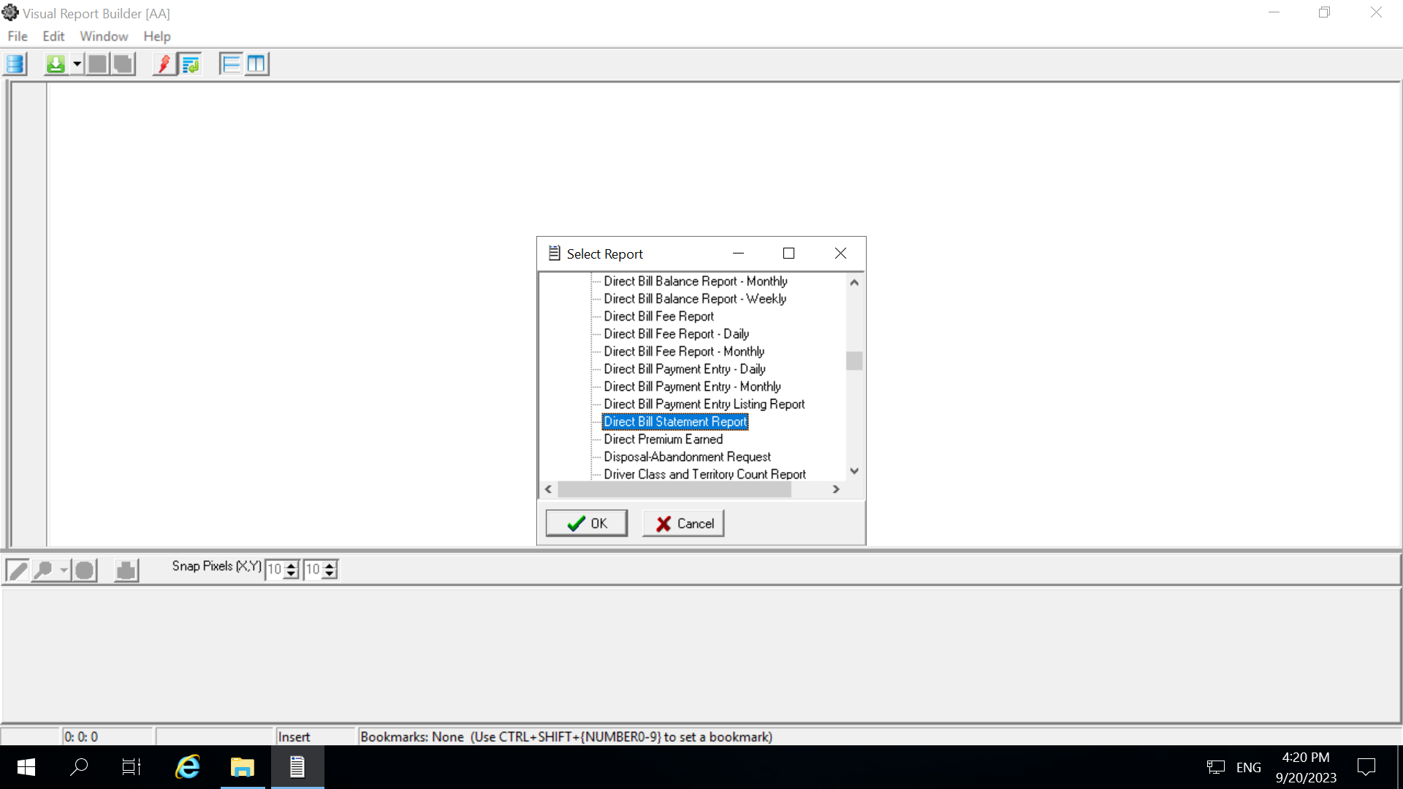  
  
Then Click Ok  
  
  
Go to Files, click Preview  
  
  
After preview  
Start date:  
End date:  
Agency:  
  
In right hand side, select the **(.)spread sheet XLS(Microsoft Excel 97)**   
  
then print  
  
You will see the below pop up window, just ignore the alert  
  
to know the status of file generation  
  
Go to below path  
**C:\Report Builder\Temp**  
  
Could see files are generated.

Note: Kindly don’t close the session, If it is closed   
Please run the report from first.  
  
As soon as files are generated, share the reports.